In bootstrap, **container**is used to set the content’s margin. It contains row elements and the row elements are container of columns. This is known **as grid system.**

There are two container classes in bootstrap:

1. **.container**
2. **.container-fluid**

The .container class provides a responsive **fixed width container**

**Output**:  
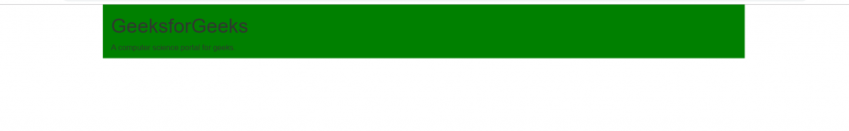

The .container-fluid class provides a **full width container**, spanning the entire width of the viewport.

* **Output**:  
  

Grid Classes:

There are four classes in Bootstrap Grid System:

* sm (for tablets)//small
* xs (for phones)xtra small
* md (for desktops)//middum
* lg (for larger desktops)//large
* xl(Larger-sized Desktops/Laptops)//extra large

# **Bootstrap Jumbotron**

**A Bootstrap jumbotron specifies a big box for getting extra attention to some special content or information.** It is displayed as a grey box with rounded corners. It can also enlarge the font sizes of the text inside it.

You can put any valid HTML or other Bootstrap elements/ classes inside a jumbotron.

The **class .jumbotron** within the <div> element is used to create a jumbotron.

**output:**  


**Nav Menu:** The .nav, .nav-item and .nav-link classes are used to create navigation menu.

**It use <ul>, <li> and a (link) element respectively.**

<ul class="nav">

            <li class="nav-item">

                <a class="nav-link" href="#">Home</a>

            </li>

</ul>

**Navigation Bar:** The .navbar class is used to create a navigation bar.

<nav class="navbar navbar-expand-sm bg-light">

            <ul class="navbar-nav">

                <li class="nav-item">

                    <a class="nav-link" href="#">Home</a>

                </li>

</ul>

</nav>

The **Carousel** is a slideshow for cycling through elements.

To create a **basic list group**, use an <ul> element with class .list-group, and <li> elements with class .list-group-item:

The .dropdown class indicates a dropdown menu.

**Glyphicons** are the icon fonts that are used in web projects.

**Typography** provides some utilities to add additional styles to texts.

Like Text-bold ,lowercase,uppercase etc